Game Booted Up

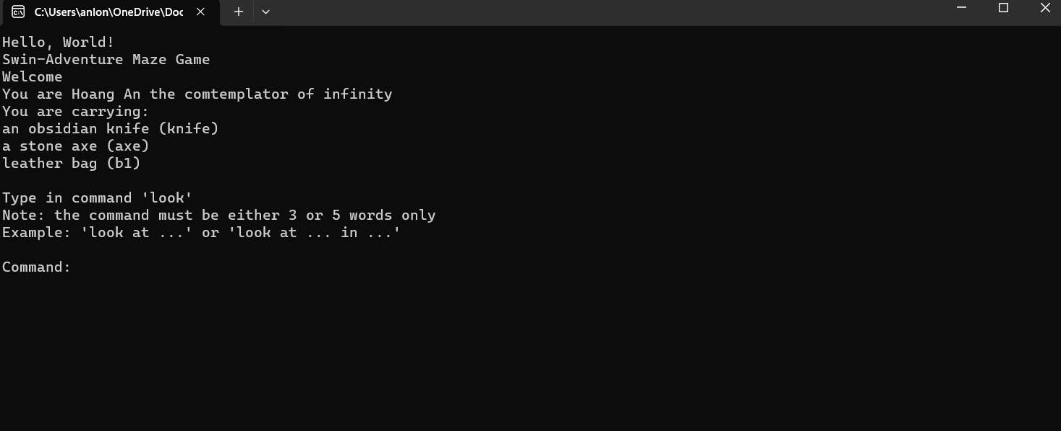

Look at item in inventory

Look at item in bag1

All possible errors in look command

